

**ADA UNIVERSITY**

**SCHOOL OF IT & ENGINEERING**

Course: Object-Oriented Analysis & Design

# HOMEWORK ASSIGNMENT

Project title: ***“Human Resources Management Systems”***

**Students:** Aytan Babayeva

Nijat Mursali

Ismayil Shahaliyev

Mehdi Hajiyev

|  |  |
| --- | --- |
| **Team member** | **Contribution to the homework** |
| Aytan Babayeva |  |
| Nijat Mursali |  |
| Ismayil Shahaliyev |  |
| Mehdi Hajiyev |  |

Instructor: **Dr. Abzatdin Adamov**

## Baku 2019

Table of Contents

Contents

HOMEWORK ASSIGNMENT 1

Baku 2019 1

1. **Preparation for Design Phase**
   1. **Functional Model V&V**
   2. **Structural Model V&V**
   3. **Behavioral Model V&V**
2. **Classes and Methods Design**
3. **Data Management Layer**
4. **User Interface Layer**
   1. **Layout**
   2. **Content Awareness**
   3. **Aesthetics**
   4. **User Experience**
   5. **Minimal User Effort**

The CEO (stands for a chief executive officer) can login into the system in the first page for our system which is called ***LoginPage.*** Login page includes two text inputs in itself: the first one is the username and the second one is password field for CEO’s information that has added previously. If the CEO adds the information correctly, he/she is able to enter the system. The next step is ***LoadingPage*** which makes the user wait for about 5 seconds in order to enter to the system and see the desired result. For this case, we have added ADA’s logo and animated gif in the footer. After several seconds, user makes it and goes to ***HomePage***which shows all the required information about all the users in the system. The information about the employee contains several fields such as employee id, name, surname, age, gender, department of employee, salary, shift and division. We have also added the login page for every user and when they enter to the system they can have different privileges such as read only or read/write. If the user is general user, he/she can only read the information about himself/herself or other users, but not able to modify the data that was set by CEO. After being an authenticated user, all the information about any employee can be shown in the system.

The following figure shows the user-interface for the ***LoginPage*** which contains several labels and two important user inputs which are username and password. We have used SQLITE database for creating the backend of our application which contained the information about the CEO who was the creator of the company. If the user enters the data correctly, he/she is directed to the ***LoadingPage***, but if enters the information incorrectly, he/she asked for the correct data by our system.

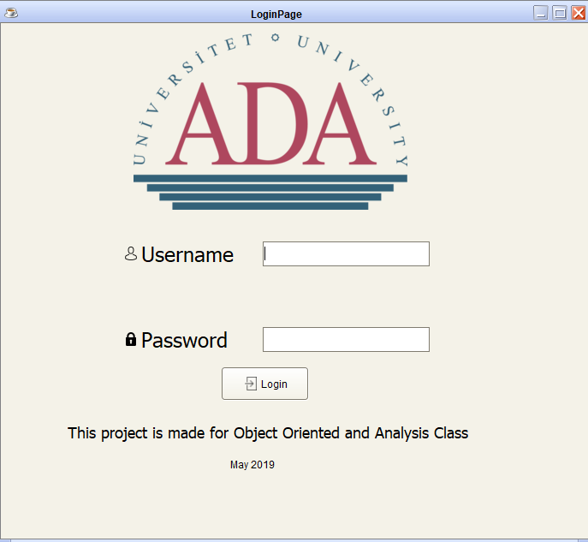

*Figure. Login Page into the System*

If the CEO enters the data correctly, he/she is being directed to the ***LoadingPage*** which again contains several labels, progress bars and one loading GIF. Progress bar has been implemented using coding in Java which took two arguments: maximum and current values. If the current value is less than maximum value, we added one to the progress bar until it got maximum. If it gets the maximum, another page which is called ***HomePage***is loaded and user sees different types of fields which we will describe in the following paragraphs.

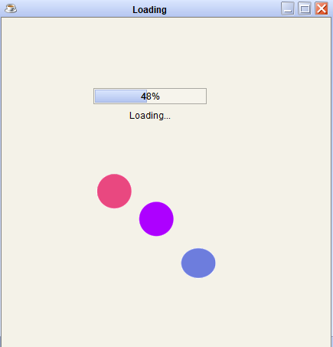

*Figure. Loading Page of the System*

The most important part of our system is ***HomePage*** which includes all the important functionalities and information about the system and employees. As shown in the Figure. the home page contains several labels, buttons and tables which we will describe more in following paragraphs.

In the top left corner, we have added the ADA’s logo and below that we have added several labels for employee id, name, surname, age, gender and other functionalities. User text inputs (which our CEO does) for the following labels can be added into the system and with the help of ***Save()*** button (we can also call it method because we have implemented it) CEO will be able to add users into the database. ***Delete()*** deletes the selected employee from the database and system with the help of methods we have implemented. ***Update()*** function updates the user’s information in the system. With the help of getting information from the database, we were able to apply ***Search()*** function as well. The usage of search function is to add the name of any user from the table into the text fields and the system automatically derives the information about the user in the text input fields in the left corner. We have also added the ***Report()*** and ***Print()*** functions which creates the PDF file with the help of Java libraries and prints the files with printer. In the right corner, we have added the table and filled it dynamically with the help of SQLITE. As mentioned above, it works dynamically, so if CEO deletes any user in the end of deleting command that user will be vanished from the table.

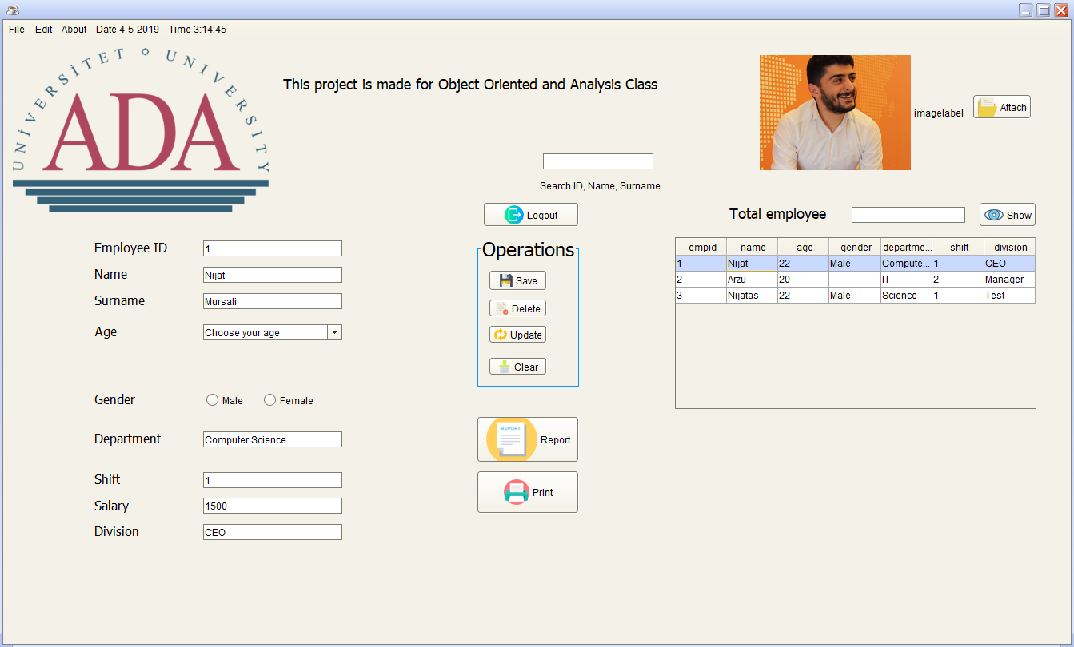

*Figure. Home Page of the System*

We have also implemented several other functions such as ***Logout(), ShowingnumberofEmployees(), Exit()*** and others. In addition, when CEO adds new data, he/she is also able to add the employee picture as seen from the Figure.

1. **Physical Architecture Layer**